**The Construction of No. 2 Dongqu Raw Coal Model and Characterization of** **Methane Formation by Pyrolysis Simulation**

LI Yao-gao, WANG Chuan-ge, ZENG Fan-gui, FAN Jing

(*Key Laboratory of Coal Science & Technology of Ministry of Education & Shanxi Province, Department of Earth Science &Engineering, Taiyuan University of Technology, Taiyuan 030024, P. R. China*)

**Abstract:** In this paper, the authors firstly constructed macromolecular structure model of No.2 Dongqu raw coal by extracting the skeleton information of coal macromolecules based on experimental data 13C-NMR, then conducted single macromolecule pyrolysis simulation and five- macromolecule pyrolysis simulation respectively for the macromolecular structure model, and finally analyzed the pyrolysis simulation by combining kinetic parameters after the simulation. It turned out that in the single macromolecular simulation, bond length and bond order affect the chemical reaction environment, mainly causing the fracture of C-C in the model, while in the five-macromolecule pyrolysis simulation, there are three reaction types for the formation of methane: (1) before the chemical system temperature rise steadily, the energy increases sharply, facilitating atom C at the edge of the molecular group is cleaved off the main chain; (2) in the medium term when the chemical system temperature rise steadily(<2600K), benzyl group connected to the aromatic nucleus on the pyrolysis fragment of the molecular group is cleaved off; (3)in the later term when the chemical system temperature rise steadily(>2600K), the cyclopentane on the main chain fragment of the molecular group is thermally broken so that the methyl group at the end of the branch falls off, giving rise to the formation of methane. At the same time, the pyrolysis experiment has been made to analyze the formation of methane and the comparison of methane formation curve between the two pyrolysis processes has also been made, which provides theoretical support for the pyrolytic reaction of coal from the microscopic point of view.

**Key words:** No.2 Dongqu Coal, Coal Macromolecule, ReaxFF, Pyrolysis Simulation, Methane

* **Corresponding author.** Tel.: +86-135-4671-1090; *E-mail address: wangchuange@tyut.edu.cn*

Since the pyrolysis of coal is an important step in the thermal transition process of coal, including coal cleaning, gasification, liquefaction, etc., it is of great significance to study coal pyrolysis for the production of coal industry. The study on the construction of coal structure model can be traced back to many years ago. In 1942, Fuchs[1] from University of Pennsylvania constructed the first coal structure model, laying the solid foundation for scholars' study on coal structure. With the development of measuring technique and computer technology, people have not only been convinced of the accuracy of the data showed by proximate analysis, ultimate analysis, Fourier Transform Infrared Spectroscopy (FTIR), X-ray Photoelectron Spectroscopy (XPS) and others on coal structure, but they verified the results by use of scientific computing software. Hatcher [2], JIA Jian-bo[3], Xiang Jian-hua[4-5], LI Wu[6],LI Zhan-Ku [7], MA Yan-ping[8] have successively constructed an increasingly reliable coal macromolecular structure model by combining with the theoretical knowledge of coal macromolecule structural model and using experimental data from FTIR, XPS, 13C-NMR, which provides a theoretical model basis for coal pyrolysis simulation and adsorption simulation. As to coal pyrolysis, ZENG Fan-gui[9] has employed the technology of Thermogravimetry-mass Spectrometry to perform pyrolysis simulation experiments on low rank coals and drew the curve graph on methane formation rate, and also applied theoretical knowledge of quantum chemistry to make calculation, recognizing four types of methane formation reactions, which is the main research method for analyzing coal pyrolysis from the perspective of quantum chemistry; LI Mei-fen[10] as well utilized the technology of Thermogravimetry-mass Spectrometry to make pyrolysis simulation experiment on seven low metamorphic coals, and studied the relationship between pyrolysis characteristics and the first coalification jump. In the process, characteristic temperature parameters and Kinetic parameters for hydrogen production can provide reference for parameter analysis of methane formation; Feng Han[11] has explored the features of thermal decomposition and gas precipitation of five lignites from Yunnan Province in southwestern China, finding that functional groups have a significant effect on weight loss of lignite and the evolution of gaseous product. Its theoretical knowledge of low temperature pyrolysis is applicable not only for the generation of CO2, CO, H2O, but other pyrolysis products of coal; A. Arenillas[12] has studied pyrolysis behavior of anthracite and bituminous coal with three different volatile matters in the calcium oxalate-based optimization system, and described the transient evolution process of volatile organic compounds, coming to the conclusion that changes of coal rank were dependent on different functional group contents. GAO Ming-jie [13] carried out pyrolysis simulation on super coal macromolecular by use of ReaxFF MD, revealing the basic law that the main reaction of formation of gases like methane in early stage in the pyrolysis process of coal macromolecular is closely related to carboxyl and methoxy groups; HONG Di-kun[14] has performed pyrolysis simulation on Zhundong Coal by using the same method and revealed secondary reaction mechanism of tar, which provides a new theoretical support for pyrolysis simulation. The predecessors have mainly analyzed coal pyrolysis test or pyrolysis simulation test of coal macromolecules individually, thus we try to combine the two and analyze its main product, methane so as to explore the certain corresponding relationship between the two.

In this paper, authors at first constructed macromolecular structure model of No.2 Dongqu raw coal and conducted. Pyrolysis simulation analysis of this model, and then they made pyrolysis experiment and verification for samples with the technology of thermogravimetry-mass spectrometry, which helped deepen people’s understanding of the pyrolysis process of coal. Based on the ReaxFF in ADF integration software, authors performed heat reactivity simulation of a single macromolecule on the model with a simulated final temperature of 3000K. In the simulation process, according to the position that different types of chemical bond ruptures in the pyrolysis process, how side chain functional bond cleave at different temperatures was clear, and the pyrolysis process of coal was described from a microscopic point of view. Since coal exists in agglomerated form[15], the pyrolysis of single macromolecules would be affected by other molecules. Authors, at the same time, carried out heat reaction simulation of a molecular group consisting of five macromolecules with the final temperature of 3000K, and analyzed reaction type as to methane formation in the process of molecular group pyrolysis simulation, providing theoretical basis for the source of methane in the process of coal pyrolysis. In addition, authors used a thermogravimetric-mass spectrometer (TG/MS) to run pyrolysis experiments, obtaining the weight loss curve[16] and methane precipitation rate curve[9]during the process of pyrolysis of the samples, and analyzed the relationship between the two to explore the relationship between simulated condition and experimental condition where methane was produced.

**1. The Sample and Experiment**

The fresh coal sample was derived from No. 2 Dongqu coal seam in Gujiao mining area of Xishan Coalfield, Taiyuan, Shanxi, and the collected raw coal (the maximum reflectivity of the vitrinite is 1.81%) was conducted proximate analysis, ultimate analysis, 13C nuclear magnetic resonance test.

Proximate analysis and Ultimate analysis (Table 1): The test was carried out by using Vario EL elemental analyzer of the German company, ELEKRTO-AUTOMATIK. During the test, 20.2g sample was weighed in a dry environment. The determination of proximate analysis is based on national standard, *Proximate Analysis Method for Coal* (GB/T212-2008), and the determination of ultimate analysis is based on national standard *Determination Methods of Carbon and Hydrogen in Coal* (GB/T476-2008). The test values of C, H, N and S are the average values of two parallel sample tests, and the O element content is calculated by minusing.

Table1 Proximate and Ultimate Analysis of No.2 Dongqu coal

|  |  |  |  |  |  |  |  |  |
| --- | --- | --- | --- | --- | --- | --- | --- | --- |
| Proximate analysis w /% | | |  | Ultimate analysis wdaf /% | | | | |
| Mad | Aad | Vdaf |  | C | H | O | N | S |
| 0.71 | 2 | 17.72 |  | 90.31 | 4.66 | 2.91 | 1.56 | 0.57 |

13C nuclear magnetic resonance (13C-NMR) test: The test was carried out by using Varian INOVA300 model superconducting nuclear magnetic resonance Spectrometer from American Agilent Technologies. The testing environment is as follows: cross-polarization (CP) technology where TOSS is adopted to suppress sideband, ZrO rotor with an outer diameter of 6mm2, magic angle with rotated speed, 6 kHz,13C detection nuclear resonance frequency, 76.425 MHz, spectral width, 3000 Hz, pulse width, 4 μs, the sampling time, 0. 05 s, cyclic delay time, 4 s, scanning times, 6000, and contact time, 5 ms.

Single coal macromolecular pyrolysis simulation: ADF/ReaxFF module[17-21] in chemical material calculation software of Dutch SCM company was adopted to hydrotreate the macromolecular structure model of No.2 Dongqu coal, and then Velocity Verlet+Berendsen method was selected to perform a simulation under normal temperature and normal pressure conditions, obtaining its structural model with the lowest energy. In the lattice at side length 5nm·5nm·5nm, an optimized No. 2 Dongqu coal macromolecular structure model was randomly put in, with the set simulation step number, 400,000, before the pyrolysis simulation. Under normal pressure, the simulated heating rate was at 25K/ps, making the temperature get raised from 297K to 3000K, with time step, 0.25fs and reaction field, HE.ff, heat reactivity simulation of the macromolecule was calculated, and finally the molecular dynamics parameters of the model and the reaction relationship between the chemical bonds were obtained.

Coal molecular group pyrolysis simulation: Based on single molecular pyrolysis simulation, Velocity Verlet+Berendsen method was also used. Then 5 optimized No.2 Dongqu coal macromolecular structure model were randomly put in the lattice at side length, 5nm·5nm·5nm, and the energy minimization simulation (Fig. 7) for this system was run, with the set simulated step number, 400,000 before the simulation pyrolysis. Under normal pressure, the simulated heating rate was 25K/ps, facilitating the temperature to raise from 297K to 3000K, with the time step, 0.25fs and the reaction field, HE.ff, heat reactivity simulation calculation of the molecular group was performed.

TG/MS experiment: The instrument of thermal analysis-quadrupole mass spectrometer, the type STA449 F3-QMS403 D from Germany company NETZSCH, was used in the pyrolysis experiment. The thermogravimetric experiment was carried out in a dry environment, and 10 mg No.2 Dongqu raw coal sample was weighed. Under vacuum condition, the temperature of the instrument got raised from 313K to 1273K, with the heating rate, 10K/min. With experiment atmosphere, nitrogen, the purge gas flow rate, 80 mL/min, and shielding gas flow rate, 20mL/min, the instrument could measure the gas product quality at a range of 1u-300u.

**2. Model Construction and Experimental Analysis**

*2.1. Model Construction and Updating of No. 2 Dongqu Coal*

*2.1.1. Model Construction*

The authors firstly analyzed 13C-NMR data characterizing coal structure, and then constructed the macromolecular structure model of No.2 Dongqu raw coal by simulating connecting aromatic structural units, fat structures and other functional groups in the structure and referring to coal macromolecular chemical structure model construction methods of JIA Jian-bo[3], XIANG Jian-hua[4-5] and so on.



Fig.1 13C-NMR Peak-differentiating Spectrum of No.2 Dongqu Coal

The software Origin 7.5 is used to conduct peak-differentiating and imitating(Fig. 1) for the original spectrum, 13C-NMR. In addition, the parameters of twelve main structures in No.2 Dongqu coal like fatty carbon and aromatic carbon were calculated (Table 2) based on the chemical shift and the relative content of each functional group.

Table 2 Structure Parameters of No.2 Dongqu Coal

|  |  |  |  |  |  |
| --- | --- | --- | --- | --- | --- |
| Aromatic Carbon | Types of Aromatic Carbon |  | Fatty Carbon | Types of Fatty Carbon |  |
| *fa* (100-220) | Total sp2 Hybridized | 0.75 | *fal* (-90) | Total sp3 Hybridized | 0.25 |
| *fa’*(100-165) | Aromatic | 0.65 | *falH* (-36) | CH or CH2 | 0.10 |
| *faC*(165-) | Carbonyl Group or Carboxyl Group C | 0.10 | *fal\**(36-50) | CH3 or Quaternary C | 0.10 |
| *faH*(100-129) | Protonated and Aromatic C | 0.44 | *falO*(50-90) | Aliphatic C Bonded to Oxygen | 0.05 |
| *faN*(129-165) | Nonprotonated and Aromatic C | 0.21 |  |  |  |
| *faP*(150-165) | Aromatic C Bonded to Hydroxyl or Ether Oxygen | 0.01 |  |  |  |
| *faS*(135-150) | Alkylated Aromatic C | 0.03 |  |  |  |
| *faB*(129-137) | Aromatic Bridgehead C | 0.17 |  |  |  |

*2.1.2. Model Updating*

According to the structural parameters of No.2 Dongqu coal, authors obtainedthe ratio of aromatic bridge carbon to pericarbon in Dongqu No. 2 coal by analyzing 13C-NMR spectrum:

Through calculation, , and then by the combination of different aromatic groups, the corresponding types and numbers of aromatic structure which is the closest to the values of in the equation can be obtained(Table 3). Consequently, it is calculated that the number of aromatic carbons in macromolecular structure model of No. 2 Dongqu coal was 117.

By referring to Table 2, authors, based on the definition of aromaticity, calculated the aromatic carbon ratio of macromolecular model to be constructed: 0.67 and thus worked out the number of carbon in macromolecular structure model of No. 2 Dongqu coal was 174.Then, it is deduced that Num(C:H:N:O)= (90.31 / 12): (4.66 / 1): (1.56 / 14): (2.91 / 16) on the base of ultimate analysis data (Table 1) ). In summary, the molecular formula of No. 2 Dongqu coal macromolecular model is .

Table3 Types and Quantities of Aromatic Structure in No.2 Dongqu Coal

|  |  |  |  |  |  |
| --- | --- | --- | --- | --- | --- |
| Types of Aromatic Structure | | Quantity | Types of Aromatic Structure | | Quantity |
| 33 | 4 Ring | 3 |  | 1 Ring | 1 |
|  | 3 Ring | 2 |  | < 3.0 Å | 1 |
|  | 2 Ring | 2 |  | 1 |

The above analysis helped obtain occurrence patterns of various elements and calculate the numbers of functional groups and the ratio among them in the macromolecular structure model of No.2 Dongqu coal. Then the software ACD/C-NMR was used to construct the coal macromolecular structure model, and software gNMR was used to calculate the chemical shift of each carbon atom so as to make comparison between the predicted spectrum and the experimental nuclear magnetic spectrum in the software Origin. If the difference between the two is large, the modification of structure model and the comparison of spectrogram were continuously being carried out until the experimental nuclear magnetic spectrum and the predicted 13C-NMR spectra were matched(Fig. 2), with the most suitable macromolecular average structure model being gotten. In the process of analyzing sample elements, since the factors affecting the determination of hydrogen are numerous and complex, the hydrogen content in the model was used as the final result. After the correction, the molecular formula of coal macromolecule is . The macromolecular structure model of No.2 Dongqu coal (Fig. 3) is connected by fatty carbon bond or carbon bond directly connected to two aromatic rings, and consists of an aromatic ring main chain, the main skeleton and three side chains with strong cross-linking property[3-5, 8, 22-23].



Fig.2 The Comparison between Experimental Spectrogram and Calculateded Spectrogram

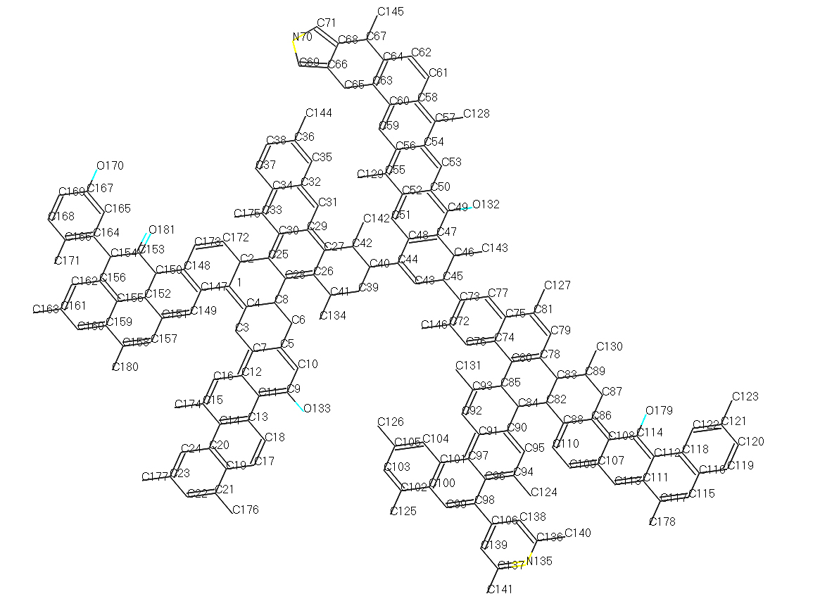

Fig.3 Macromolecular Model of No.2 Dongqu Coal

*2.2. The Pyrolysis Simulation of No. 2 Dongqu Coal Structure Model*

*2.2.1. The Pyrolysis Simulation Analysis of Single Coal Macromolecular*

During the pyrolysis simulation of single coal macromolecule, the lowest energy configuration was calculated(Fig. 4). After the simulation, the energy at the start point and the energy at the end point (Table 4) were selected for comparison.

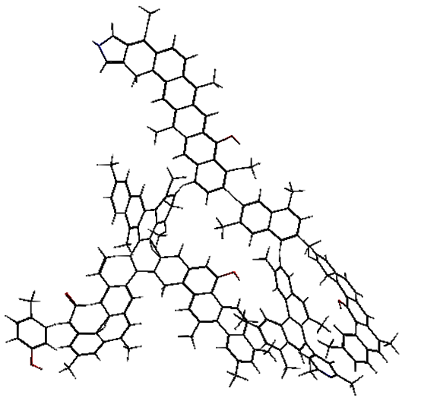

Fig.4 Energy- minimum Configuration of No.2 Dongqu Coal

Table4 Energy (kcal /mol) Comparison before and after Single Molecular Dynamics

|  |  |  |  |  |  |  |  |
| --- | --- | --- | --- | --- | --- | --- | --- |
| Simulated Condition | Ebond | Eatom | Etors | Evdw | Echarge | Etotal | |
| Start | -62408.01 | 782.27 | 223.29 | 20311.21 | 806.09 | | -36384.39 |
| End | -69678.87 | 960.86 | 191.72 | 16381.67 | 901.39 | | -43087.92 |

From Table 4, it is can be seen that the total energy is reduced from -36384.39 kcal/mol to -43087.92 kcal/mol, and that the bond energy is reduced from -62408.01 kcal/mol to -69678.87 kcal/mol after the single molecular dynamics simulation, causing the torsional energy and the energy of van der Waals force were reduced accordingly. The reason for the phenomenon is that various functional group fragments were generated inside the system during the pyrolysis process, resulting in the reduction in total energy, bond energy, torsional energy, and energy of van der Waals force in the system. However, the atomic energy in the system increased from 782.27 kcal/mol to 960.86kcal/mol, and the charge energy increased from 806.09 kcal/mol to 901.39kcal/mol, indicating that the system’s stability got enhanced after macromolecule was splited into fragments in the simulated condition where temperature rose in this system.

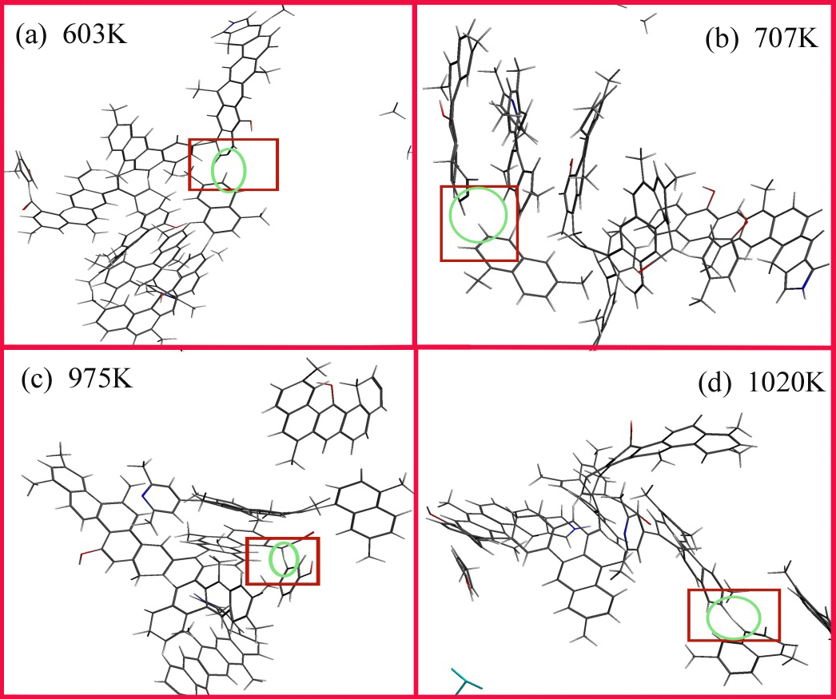

Fig.5 Pyrolysis Process of Single Macromolecule

The macromolecule was hydrotreated in the lattice so as to obtain the lowest energy configuration, and pyrolysis reaction simulation of the single macromolecule was conducted. The reaction process was as follows: At around 603K, the first macromolecular fragment was cleaved off from the main structure (Fig. 5_a), and at the same time, the total energy of the macromolecule in this chemical environment increased due to the increase of the temperature inside the system,, so the relatively active C73-C45 bond on the main chain of the macromolecular structure model ruptured, causing molecular fragments containing the two branched chain N135, O179 detached from the main chain, resulting in two macromolecular fragments.

The second fragment was detached from the first macromolecular fragment (Fig. 5_b) when the temperature was at about 707K. At 603K, there were two branched chains in the macromolecular fragment detached from the main chain, and the fatty carbon bond C84-C82 connecting the two branched chains ruptured, causing the decrease of cross-linking property. In such chemical environment, the relatively active C83-C78 ruptured, causing the falling of the branched chain containing O179 from the fragment just detached from the main chain.

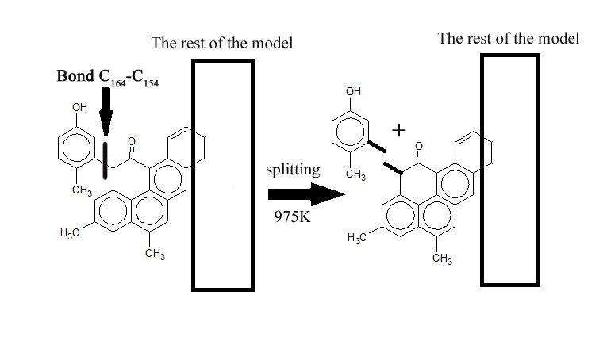

Fig.6 Chemical reaction process at 975K

The third fragment fell off from the structure (Fig. 5_c) when the temperature was around 975K. In the chemical environment, the surrounding C got relatively active due to O170 and O181, causing the rupture of C164-C154 (Fig. 6) and thus the generation of a p-methylphenol.

The fourth fragment fell off from the main structure (Fig. 5_d) when the temperature was around 1020K. After the second fragment fell off, C85-C80 ruptured, producing a molecular fragment and dimethylnaphthalene. It showed that the rupture of the main bond during coal pyrolysis occurs in a relatively low temperature environment (<1100K) mostly.

*2.2.2. The Pyrolysis Simulation Analysis of Coal Molecular Group*

The lowest energy configuration(Fig. 7) was worked out during the pyrolysis simulation process of molecular group consisted of the five coal structure model molecules. After the simulation, the process of methane formation was clear and methane precipitation rate curve were obtained (Fig. 8), and the energy at the start point and that at the end point(Table 4) were selected for comparison.

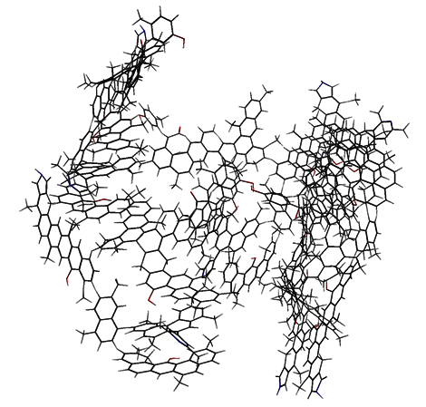

Fig.7 Energy- minimum Configuration of Molecular Group

Table5 Comparison of Energy (kcal /mol) before and after Molecular Dynamics Simulation

|  |  |  |  |  |  |  |
| --- | --- | --- | --- | --- | --- | --- |
| Simulated Condition | Ebond | Eatom | Etors | Evdw | Echarge | Etotal |
| Start | -298394.73 | 4804.16 | 958.85 | 81883.61 | 4017.62 | -215469.43 |
| End | -298501.77 | 4844.86 | 952.87 | 81839.13 | 4068.73 | -215606.38 |

According to Table 5, it can be seen that the total energy was reduced from -215469.43 kcal/mol to -215606.38kcal/mol, and that bond energy was reduced from -298394.73kcal/mol to -298501.77kcal/mol through molecular group dynamics simulation, causing both torsional energy and the energy of van der Waals force were correspondingly reduced. The reason for the phenomenon is that the molecular group generated various functional group fragments in the pyrolysis process under the corresponding chemical environment, resulting in the reduction of of total energy, bond energy, torsion energy and the energy of Van der Waals' force inside the system. However, atomic energy and charge energy inside the system increased. The result corresponded to the energy changes before and after the single molecular dynamics simulation, and it conformed to the basic principle of system energy conservation.



Fig.8 Methane Precipitation Rate Curve during the Process of Molecular Group Pyrolysis Simulation



Fig.9 The Potential Energy Changing Curve during the Process of Molecular Group Pyrolysis Simulation

From the methane precipitation rate curve (Fig. 8) in the pyrolysis simulation process, it can be seen that methane starts to precipitate when the temperature is about 2200K, and that the precipitation rate reaches the maximum when it is at 2580K and the rate is close to zero when the final temperature for pyrolysis is 3000K. During the pyrolysis process, the system energy in the method NVT increases rapidly due to the action of the force field and the rapid temperature change at the beginning of the simulation, which drives the potential energy of the system (Fig. 9) rapidly to increase. After a short period of time, the system pyrolysis reaction is stable, and the potential energy of the system decreases rapidly. Then the subsequent overall trend tends to increase as time goes by.

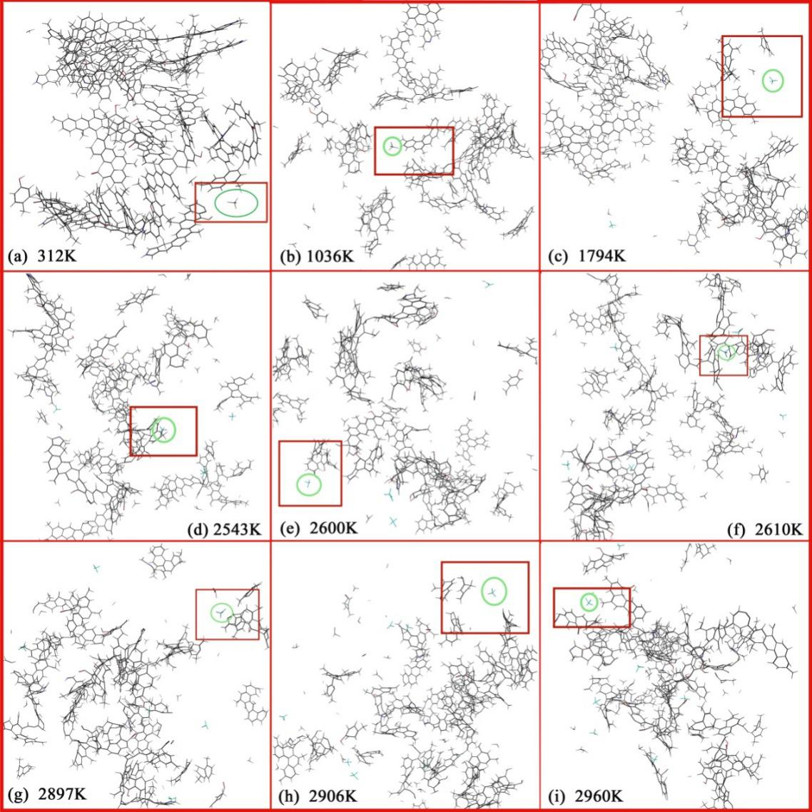

Fig.10 Description of the pyrolysis process of molecular group

In the pyrolysis simulation process of No.2 Dongqu Coal macromolecular structure model, the formation of methane (Fig. 10) is mainly from the primary or secondary detachment of methyl groups on several major side chain functional groups of the coal structure in the force field system, ReaxFF.

In SCM MOVIE, the method of methane formation was tracked. When it was around 312K, the methyl group C130 was detached due to the breaking of the bond, C130-C89, and combined with hydrogen ions, thus the first methane molecule was formed (Fig. 10_a). At the beginning of the simulation process, the rapid increase of the system's potential energy led to the drastic change of the molecular group composed of the five macromolecular models in the system, so relatively unstable C130 at the edge of the molecular group was detached and formed a benzyl group.

The second methane molecule was formed (Fig. 10_b) when it was around 1036K, for the side branch chain broke from the molecular group, and the breaking of bond C163-C161 on this branch facilitate the methyl group C176 to detach from the quaternary benzene ring to form a benzyl group.

The third methane molecule was produced (Fig. 10_c) when it was at around 1794K, for cyclohexane C28-C8, C8-C6 in the molecular ruptured, causing thatthe bond between C8-C4 connected, and then the force field under the temperature rendered C8 to detach from the side chain fragment to form methane.

The fourth methane molecule was formed (Fig. 10_d) when it was around 2543K, for C180 was detached fromC180-C158 on the side chain fragment in the molecular group, forming benzyl and.

The fifth methane molecule was formed (Fig. 10_e) when it was around 2600K, for C123  from C123-C121 on the side chain fragment in the molecular group is closer to O179, and the electronegativity of O is larger than that of C, coupled with strong force field and the action of O in the chemical environment, C123 fell off the side chain to form benzyl group.

The sixth methane molecule was formed (Fig. 10_f) when it was around 2610K, for the bond between C42-C40 ruptures under the condition, leading to the large distance between C142-C42 and the relatively stable C27, and C142 was detached from the main chain fat fragment to form methane.

The seventh methane molecule was formd (Fig. 10_g) when it was around 2897K. Under the simulated conditions, the molecular backbone chain ruptured and formed a main chain fragment. At this time, the chemical bonds in C44-C40 and C42-C40 have been broken, C40 methyl group was exposed to the most unstable far end of the molecular fragment, and then the bond in C40-C39 was broken, causing C40 was detached from fat fragment of the main chain to form methane.

After that, in the second simulation reaction process (Fig. 10_h), when it was around 2906K, the methane labeled in the figure decomposes to form a methyl group and a hydrogen ion due to the influence of the force in the chemical environment.

The last methane (Fig. 10_i) was formed when it was around 2960K. At that time, the molecular group has been cleaved into more than one molecular fragment, and in the chemical environment, C131-C93 ruptured, causing C131 was detached from a side chain fatty group in the molecule and formed methane.

Table6 The Properties of Broken Bonds in Simulated Pyrolysis Process of Molecular Group

|  |  |  |
| --- | --- | --- |
| Bond type | Length/ Å | Bond |
| C130-C89 | 1.52 | 1.24 |
| C176-C21 | 1.48 | 1.22 |
| C8-C4 | 1.5 | 1.43 |
| C180-C158 | 1.48 | 1.52 |
| C123-C121 | 1.48 | 1.37 |
| C40-C39 | 1.52 | 1.19 |
| C134-C41 | 1.52 | 1.21 |
| C131-C93 | 1.48 | 1.20 |

According to the characterizations of C-C bond length and bond level(Table 6), the bond length of the C-C bond that breaks to form a methyl group is relatively large, and there is not big difference among the bond levels. Based on the basic principle that the bond which is longer is more unstable, it can be concluded that bond length is the main factor affecting the rupture of C-C bond to form methyl group, and bond level is the secondary factor in the process of generating methane.

From the pyrolysis simulation process of five coal structure model moleculars, it can been seen that firstly the increase of potential energy in the system propelled the most active methyl group at the edge of the molecular group fell off to form methane, and then the main structure in the molecular group composed of five coal structure model molecules underwent thermal cracking reaction before it was at 1020K. Specifically, the main side chain functional groups were successively detached from the molecular group, and they were also subjected to secondary cracking due to their own chemical environment, subsequently, the corresponding methyl groups were successively detached to form methane during heating. It is worth noting that in the process of methane formation, especially when it was at around 2900K, some methane decomposed into methyl and hydrogen ions under high temperature, and the amount of hydrogen ions and methyl groups will change slightly. In such reaction, the produced methyl possessed a higher activity and methane would be regenerated in subsequent reactions.

*2.3. Thermogravimetric-mass Spectrometry Analysis of Samples*

Through experiments, the sample weightlessness and weightlessness rate curve (Fig. 11) and methane precipitation rate curve (Fig. 12) were obtained.



Fig.11 Sample Weightlessness Curve and Weightlessness Rate Curve

According to the figure 11, when it is less than 600K, the reaction is to remove the adsorbed water and adsorbed gas from the sample by heat removal. Since it is 600K, the reaction has been violent and the samples begin to pyrolyse. the weight loss of the samples being obvious and the maximum weight loss rate reaching at 0.08%/K when it is 785K. At this time, the macromolecular structure of the coal depolymerized and decomposed, and a large amount of volatile gas is produced. The sample weight loss rate is 5.92% and 5.02% respectively when it is during 600K to 785K and 785K to 866K. The sample is subjected to pyrolysis and tar yield increased when it is the 785K when the weight loss rate is maximized. The tar precipitation amount decreases when it is more than 785K and a large amount of gas is generated. With increasing temperature, the weight loss rate of the sample declines, and the volatile matters are completely precipitated, during which, the main reaction is on the secondary reaction of the pyrolysis products, and the gases mainly including methane are precipitated.



Fig.12 Methane Precipitation Rate Curve during Pyrolysis of Samples

In coal pyrolysis, methane is formed through three main types of reaction: it is formed by secondary cleavage of long-chain aliphatic hydrocarbons, rupture of short aliphatic chains, and the detachment of methyl groups in methyl ester fat side chains linked by methoxy groups, alcohol functional groups, and hetero atoms; it is formed by the rupture of C-C bond from methyl group linked to the naphthene and the naphthenic structure during the high temperature; it is formed by the release of methyl group in the alicyclic structure formed by the condensation polymerization of the aromatic structure in the coal.

From the methane precipitation rate curve (Fig.12), it can be seen that the rate starts to increase gradually when it is 680K, reaching the maximum value when it is 820K, and then decreases. The temperature 820K when methane precipitation amount is maximized is greater than the temperature 785K when weight loss is maximized. The reason may be that the free radical generated by the rupture of bridged bond in the coal reaches a maximum when it is 820K, and then sharply drops to generate a large amount of hydrogen, the active semi-coke being hydrogenated.



Fig.13 Comparison of Methane Precipitation Temperature in Pyrolysis Simulation and Experiment

Through comparing methane precipitation temperature in pyrolysis simulation and experiment (Fig.13), it can be found that in pyrolysis simulation, the initial temperature when methane precipitined was 2200K and the termination temperature was 2900K while in the pyrolysis experiment, the initial temperature when methane is precipitined is 680K and the termination temperature is 1220K. Combined with the corresponding relationship of other temperature points, it can be seen that in the simulation and experiment, the temperature point at which methane is precipitated has a good linear correlation.

**3. Conclusions**

Through the construction of a large molecular structure model of No.2 Dongqu coal, pyrolysis simulation for single macromolecular structure has been conducted, thus, the information on the chemical bond cleavage in the structure under the conditions of specific temperature being obtained. Continuously, the pyrolysis simulation of molecular group consisting of 5 macromolecular structures is conducted, and methane formation rate curve gets obtained. By combining the characterization of the large molecular structure model of No. 2 Dongqu coal and simulation results to make analysis, the main conclusions are as follows:

(1) When constructing the macromolecular model of No.2 Dongqu raw coal, through calculation, the ratio of aromatic bridge carbon to pericarbon is 0.35, and the aromatic carbon ratio is 0.67. The experimental spectrum is basically consistent with the simulated spectrum, so the structure of the macromolecular model is relatively reasonable, and molecular formula is .

(2) During the pyrolysis simulation of No.2 Dongqu raw coal, under the condition of relatively low temperature (<1100K), the main functional groups in the coal undergo a cleavage reaction, so the corresponding side chain functional groups are detached from the main chain, and with the rising temperature, the chemical environment in the system tends to be stable.

(3) In the process of pyrolysis simulation, methane is formed through three main ways: before the temperature rises stably in the simulated system, the system energy increases sharply, promoting C atom at the edge of the molecular group to cleave off the main chain; in the medium period when system temperature rises stably (<2600K), the benzyl group attached to the aromatic nucleus on the pyrolysis fragment of the molecular group falls off; in the later period when system temperature rises stably (>2600K), the cyclopentane on the backbone segment of the molecular group opens because of pyrolysis, causing the methyl group at the end of the branch to fall off to form methane. At the same time, there may be a reaction in which methane is dehydrogenated to a methyl group influenced by the chemical environment surrounding the oxygen atom.

(4) During the pyrolysis experiment, methane is also formed by three main ways, which is corresponding to that in pyrolysis simulation.

(5) After analyzing methane, the product of samples after simulated pyrolysis, We came out the initial temperature when methane precipitates was 2200K, and the termination temperature was 2900K. The temperature point of methane precipitation in the simulation was linearly related to that in the experiment. The pyrolysis simulation method provides an effective means.for studying methane formation during coal pyrolysis.

**Acknowledgements**

This work was financially supported by NSFC-Shanxi Coal-based Low Carbon Joint Fund (Project is Experiments and Molecular Modeling of Multi-scale Structural Characteristics of Coking Coal and Its Relationship with Pyrolysis Reactivity, No.U1510102).

**References**

[1] Fuchs W, Sandhoff A G. Theory of Coal Pyrolysis[J]. Ind.eng.chem, 2002, 34:567-571. https://doi.org/10.1021/ie50389a010

[2] Hatcher P G, Faulon J L, Wenzel K A, et al. A structural model for lignin-derived vitrinite from high-volatile bituminous coal (coalified wood)[J]. Energy & Fuels, 1992, 6(6):813-820. https://doi.org/10.1021/ef00036a018

[3] JIA Jian-bo, ZENG Fan-gui, SUN Bei-lei. Construction and modification of macromolecular structure model for vitrinite from Shendong 2-2 coal[J]. [Journal of Fuel Chemistry and Technology](javascript:void(0)) , 2011, 39(9):652-657. https://doi.org/10.3969/j.issn.0253-2409.2011.09.003

[4] XIANG Jian-hua, ZENG Fan-gui, LIANG Hu-zhen, et al.Model construction of the macromolecular structure of Yanzhou coal and its molecular simulation[J]. [Journal of Fuel Chemistry and Technology](javascript:void(0)) , 2011, 39(7):481-488. <https://doi.org/10.1016/S1872-5813(11)60031-5>

[5] XIANG Jian-hua, ZENG Fan-gui, LI Bin, et al, Construction of macromolecular structural model of anthracite from Chengzhuang coal mine and its molecular simulation[J]. [Journal of Fuel Chemistry and Technology](javascript:void(0)), 2013, 41(4):391-399. <https://doi.org/10.1016/S1872-5813(13)60022-5>

[6] WU L, ZHU Y. Structural Characteristics of Coal Vitrinite during Pyrolysis[J]. Energy & Fuels, 2014, 28(6):3645-3654. https://doi.org/[10.1021/ef500300r](http://dx.doi.org/10.1021/ef500300r)

[7] LI Z K, WEI X Y, YAN H L, et al. Insight into the structural features of Zhaotong lignite using multiple techniques[J]. Fuel, 2015, 153:176-182. <https://doi.org/10.1016/j.fuel.2015.02.117>

[8] MA Yan-ping, XIANG Jian-hua, LI Mei-fen,et al. Macromolecular structural model of the pyridine extracted residue of vitrain from No.3 coalbed, Liu lin and molecular simulation[J]. [Journal of Fuel Chemistry and Technology](javascript:void(0)), 2012, 40(11):1300-1309. https://doi.org/10.3969/j.issn.0253-2409.2012.11.004

[9] ZENG Fan-gui, JIA Jian-bo, Reaction Types and Kinetics of Methane Generation from Huolinhe Lignite Pyrolysis by TG/MS Experimen and Quantum Chemical Calculations[J]. Acta Physico-Chimica Sinica, 2009, 25(6):1117-1124. https://doi.org/[10.3866/PKU.WHXB20090611](http://dx.doi.org/10.3866/PKU.WHXB20090611)

[10] LI Mei-fen, ZENG Fan-gui, SUN Bei-lei, et al. Evolution Kinetics of Hydrogen Generation from Low Rank Coal Pyrolysis and Its Relation to the First Coalification Jump. [J]. Acta Physico-Chimica Sinica, 2009, 25(12):2597-2603. https://doi.org/[10.3866/PKU.WHXB20091218](http://dx.doi.org/10.3866/PKU.WHXB20091218)

[11] HAN F, MENG A, LI Q, et al. Thermal decomposition and evolved gas analysis (TG-MS) of lignite coals from Southwest China[J]. Journal of the Energy Institute, 2016, 89(1):94-100. <https://doi.org/10.1016/j.joei.2015.01.007>

[12] Arenillas A, Rubiera F, Pis J J. Simultaneous thermogravimetric–mass spectrometric study on the pyrolysis behaviour of different rank coals[J]. Journal of Analytical & Applied Pyrolysis, 1999, 50(1):31-46. <https://doi.org/10.1016/S0165-2370(99)00024-8>

[13] GAO Mingjie, LI Xiaoxia, GUO Li. Pyrolysis simulations of Fugu coal by large-scale ReaxFF molecular dynamics [J]. Fuel Processing Technology, 2018, 178:197-205. https://doi.org/10.1016/j.fuproc.2018.05.011

[14] HONG Dikun, GUO Xin. Molecular dynamics simulations of Zhundong coal pyrolysis using reactive force field, 2017, 210:58-66. http://dx.doi.org/10.1016/j.fuel.2017.08.061

[15] Shui H, Koyo Norinaga A, Iino M. Characterizations of Aggregation States of Coal Soluble Constituents at Solid State[J]. Energy & Fuels, 2002, 16(1):69-73. https://doi.org/[10.1021/ef010162w](http://dx.doi.org/10.1021/ef010162w)

[16] LIU S, ZOU C, ZHAO J, et al. Speciation of Sulfur and Regularity of Pyrolysis Gas Evolution in Different Coking Coals[J]. Coal Conversion, 2018. https://doi.org/10.19726/j.cnki.ebcc.2018.02.004

[17] ZHENG M, WANG Z, LI X, et al. Initial reaction mechanisms of cellulose pyrolysis revealed by ReaxFF molecular dynamics[J]. Fuel, 2016, 177(AUG):130-141. <https://doi.org/10.1016/j.fuel.2016.03.008>

[18] LI G Y, WANG F, WANG J P, et al. ReaxFF and DFT study on the sulfur transformation mechanism during the oxidation process of lignite[J]. Fuel, 2016, 181:238-247. <https://doi.org/10.1016/j.fuel.2016.04.068>

[19] Castro-Marcano F, Kamat A M, Jr M F R, et al. Combustion of an Illinois No. 6 coal char simulated using an atomistic char representation and the ReaxFF reactive force field[J]. Combustion & Flame, 2012, 159(3):1272-1285. <https://doi.org/10.1016/j.combustflame.2011.10.022>

[20] Bhoi S, Banerjee T, Mohanty K. Molecular dynamic simulation of spontaneous combustion and pyrolysis of brown coal using ReaxFF[J]. Fuel, 2014, 136(6):326-333. <https://doi.org/10.1016/j.fuel.2014.07.058>

[21] Castro-Marcano F, Jr M F R, Duin A C T V, et al. Pyrolysis of a large-scale molecular model for Illinois no. 6 coal using the ReaxFF reactive force field[J]. Journal of Analytical & Applied Pyrolysis, 2014, 109:79-89. <https://doi.org/10.1016/j.jaap.2014.07.011>

[22] Mathews J P, Chaffee A L. The molecular representations of coal – A review[J]. Fuel, 2012, 96(7):1-14. <https://doi.org/10.1016/j.fuel.2011.11.025>

[23] Castro-Marcano F, Lobodin V V, Rodgers R P, et al. A molecular model for Illinois No. 6 Argonne Premium coal: Moving toward capturing the continuum structure[J]. Fuel, 2012, 95(1):35-49. <https://doi.org/10.1016/j.fuel.2011.12.026>